





**SUBMITTED BY: Somesh nawandar**

2014AAPS318H

**SUBMITTED TO: Prof A Vijaylakshmi**

OFF CAMPUS FACULTY.

**ACKNOWLEDGMENT**

I am deeply indebted to my instructor **Prof. A vijaylakshmi** from the BITS PILANI whose help, stimulating suggestions and encouragement helped me in all the time of research for and writing of this project.

I would like to thank **Mr. P.R CHOUBEY (DGM)** for creating opportunities to undertake me in the esteemed organization and for giving me an opportunity to work with NOC transmission department.

I would like to thank **Mrs. Priya Gupta (Senior Executive)** my project guide for all the help and guidance extended to me by them in every stage during my training and helped me understand concepts related to the project and have solved my innumerable doubts without any reluctance.

All the team members were very encouraging and supportive during the whole period. I am really grateful for their constant support and help.

My friends also supported me in my research work. I want to thank them for all their help, support, interest and valuable hints.

(**somesh nawandar)**

**BIRLA INSTITUTE OF TECHNOLOGY AND SCIENCE**

**PILANI (RAJASTHAN)**

**Station:** TATA Communications **Centre:**  Pune

**Duration:** 8 weeks **Date Of Start:** 23rd May, 2016

**Date of Submission:** 14th July, 2016

**Title of Project:**  Enabling invisible alarms for Efficient root cause analysis

**Details of Student:** Somesh Nawandar| 2014AAPS318H | Electronics and communication Engineering

**Name and Designation of Experts:** Mr. P R Choubey – Manager

Mrs Priya Gupta – Mentor

**Name of the PS Faculty:** Ms. A Vijaylakshmi

**Keywords:**  Communication, PDH, SDH, Virtual network, Invisible alarms, Spotlight, ECI-EMS.

**Project Areas:** Automation tools (SPOTLIGHT)

**ABSTRACT**

The principle objective of this project report is to demonstrate the use and working of the basic technology being used in the transmission of the digital signals that is the SDH (Synchronous Digital Hierarchy) technology. This project also aims at studying the basic working of the Network Operations Centre (NOC) and the various technologies used there.

To start, the first part of the report gives a brief introduction about the company TATA Communications Limited. Then it deals with the working of NOC (Network Operations Centre) and SOC (Service Operations Centre). Furthermore, it describes the whole process that is being carried out in the Service operation centre (SOC). From the booking of Trouble ticket to the troubleshooting of the port and circuit level alarms.

The second part deals with the techniques used in digitalization of the signals. It also deals with the pre-SDH technology i.e. PDH (Plesiochronous Digital Hierarchy) and its various disadvantages that lead to the invention of SDH technology.

The third part covers the SDH networking which describes the topologies of the network on which traffic flows.

The fourth part essentially describes the theory behind the project and describes in detail what the project was about and the outcome on completion of the project.

Upon completion of this report we will understand the technologies used in transmission of digital signal and various types of alarms during network fault and briefly about automation tool **SPOTLIGHT.**

**TABLE OF CONTENTS**

|  |  |
| --- | --- |
| **Topic** | **Page No.** |
| I.            TATA Communications Limited | 5 |
| 1.      Network Operation Centre (NOC) | 6 |
| a)      Main features of NOC | 6 |
| b)      Primary responsibilities of NOC personnel | 6 |
| 2.      Service Operation Centre (SOC) | 7 |
| a)      Process of SOC | 8 |
| b)      Service Types | 8 |
| c)      Database tools | 8 |
| d)     Ticketing tools | 8 |
| e)      Equipments used | 9 |
| f)       Non-Commercial Change Management (NCCM) | 9 |
| g)        Severity | 9 |
| h)        Customer Type | 10 |
| II.            Overview of Modulation Techniques used to digitalize a signal | 10 |
| 2.      Plesiochronous Digital Hierarchy | 11 |
| a) tributary access in PDH | 11 |
| b) disadvantages of PDH | 12 |
| 3.      Synchronous Digital Hierarchy | 13 |
| a)      Why did SDH emerge? | 13 |
| b)      Characteristics of SDH-Bit Rate levels | 13 |
| c)      Advantages of SDH | 14 |
| d)     Disadvantages of SDH | 14 |
| e)        Alarms in SDH Network | 15 |
| f)      Troubleshooting Port level alarms | 18 |
| g)        Causes of SDH Alarms | 20 |
| III.            SDH Networking | 21 |
| 1.      Introduction | 21 |
| 2.      Classification of Topology Structures | 22 |
| IV.            Automation Project (‘SPOTLIGHT’) | 24 |
| a. Virtual Network | 25 |
| b. enabling invisible alarms | 26 |
| c. project to enable invisible alarms | 26 |
| V.            Bibliography | 29 |

**LIST OF FIGURES**

|  |  |
| --- | --- |
| FIGURE NO | DESCRIPTION OF THE FIGURE |
| 1.1 | Service operations centre |
| 2.1 | Three series PDH digital signal hierarchies |
| 2.2 | Dropping signal |
| 2.3 | Adding signal |
| 2.4 | Step by step PDH multiplexing |
| 2.5 | Bit rate levels |
| 2.6 | Byte interleaved multiplexing method |
| 2.7 | Jittered signal |
| 2.8 | Loss of signal alarm (LOS) |
| 2.9 | No loss generated( smooth transmission) |
| 2.10 | LOS and AIS |
| 2.11 | LOS And AIS |
| 2.12 | RDI(remote defect indication) |
| 2.13 | Testing link |
| 2.14 | Testing link |
| 2.15 | Out of frame (OOF) |
| 2.16 | Loss of frame (LOF) |
| 3.1 | Chain network |
| 3.2 | Star network |
| 3.3 | Tree network |
| 3.4 | Ring network |
| 3.5 | Mesh network |
| 4.1 | Virtual network |
| 4.2 | Alarm on virtual network |
| 4.3 | Network element on ECI |
| 4.4 | Port of the NE(network element) |
| 4.5 | Alarm severity assignment |
| 4.6 | Master mask |
| 4.7 | Enabled alarm |

1. **TATA COMMUNICATION LIMITED**

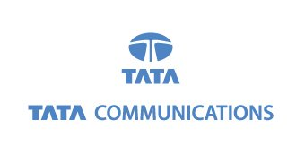

**Tata Communications Limited;** (formerly **VSNL**) is a leading Indian global telecommunication company with its headquarters located in Mumbai. It owns a submarine cable network, and also rents data centre and colocation space. It operates India’s largest data centre in Pune. Tata Communications acquired Teleglobe, a company based in Canada, and Dish net DSL, an Indian company, and is the largest shareholder in South African operator Neotel. Tata Communications currently has a cable network of more than 235,000 kilometres.

It was founded as VSNL (Videsh Sanchaar Nigam Limited) in 1986. VSNL was the first Indian PSU to be listed in the NYSE (New York Stock Exchange) in 2000. In 2002 Tata Communications acquired a 45% stake in VSNL. The international arm of VSNL, *VSNL International* was launched in 2004. VSNL, formerly owned by the Government was taken over by the Tata Group and renamed Tata Communications Ltd on 13 February 2008.

The main **vision** of this company is to deliver a world of communications to advance the reach and leadership of its customers.

It is committed towards building long-lasting relationships with customers and partners and leads the industry in responsiveness and flexibility.

Tata Communications Limited (TCL) being a telecommunication industry is responsible for monitoring, power failure, communication line alarms that may affect the coding.

**I being an electronics and communication engineer was a part of Network Operation Centre (NOC) which is considered as the heart of the Telecom Company.**

1. **NETWORK OPERATION CENTER**

Network Operations Centre (NOC, pronounced like the word knock) is one or more locations from which network monitoring and control, or network management, is exercised over a computer, telecommunication or satellite or a network

NOCs are implemented by business organizations, public utilities, universities, and government agencies that oversee complex networking environments that require little to no downtime*.

1. **Main features of NOC**

* Network monitoring, troubleshooting and fault finding through EMS and NMS.
* To perform trouble shooting
* To analyse problems
* Contact Escalate problems to appropriate stake holders
* To remedy the problem in severe conditions like power failure or optical fibre cut in the unit

1. **Primary responsibilities of NOC personnel**

* Network monitoring
* Incident response
* Communications management
* Escalating/reporting

**\*Downtime: it is used to refer to a period when a system is unavailable or system fails to perform its primary functions.**

1. **SERVICE OPERATION CENTER (SOC)**

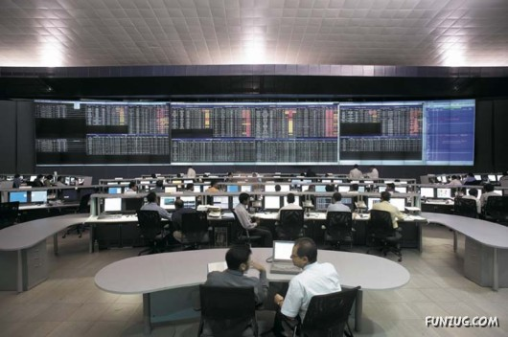

Fig 1.1 service operation center

Service Operation Centres (SOC) arose with the introduction of service quality management concept. Service Operation Centre or SOC is an organizational “department” that monitors the quality of the overall service and take the necessary actions in the case of service degradations and outages. The main data source for the SOC screens will be the SQM (Service Quality Management). **Service quality** is a comparison of expectations with performance. Service quality also demands a simple and easy-to-use user interface. With this interface, Network Operations Centre (NOC) staff and service managers can monitor service-quality objectives against thresholds. These thresholds may be internal targets for the network operator. Or they could be derived from Service Level Agreement (SLA) definitions.

The operators in the SOC will continuously monitor SQM and coordinate with other departments to decrease the MTTR (Mean Time to Restore which is the average time taken to recover from any failure) of the service outages.

A typical operator has a Network Operation Centre or NOC inside its organization. This NOC, manages the Network Management system (NMS), monitors faults and events, track the performance of the network and troubleshoot the problems at the first hand. (L1 (Level 1) support). However, as the name implies, the main purpose of the NOC is to manage the network.

The network is only one part of the service. There are other components from IT. There may even some components from outside the organization such as content. NOC’s primary responsibility is to deal with those network specific complex problems. They should not communicate with the content provider to resolve a problem.

Because a network service provider’s main product is “network”, up to now, NOCs were sufficient to achieve overall assurance activities. But, as the services got more diverse and complex, SOC concept became much more logical.

1. **Process of SOC**

Customer complaint is termed as **docket** and depending upon whether docket is reactive (booked by customer) or proactive (booked by NMS proactive team). Dockets are handled by SOC team. The ticket is booked by Customer Help Desk (CHD) team in Remedy/ Viznet that are the two ticketing tools. The tickets are of two types:

**Incident ticket**: one ticket booked for one issue

**Problem ticket**: one ticket booked for multiple issues.

1. **Service Types**
2. ILL: Internet Leased Line
3. IPLC: Internet Private Leased Circuit
4. NPLC: National Private Leased Circuit
5. NDE: National Dedicated Ethernet
6. VPN: Virtual Private Network
7. GVPN: Global Virtual Private Network
8. DGE: Dedicated Gigabit Ethernet
9. **Database Tools**
10. Crammer
11. CBOSS

These give the circuit routing details.

1. **Ticketing Tools**
2. Viznet
3. BMC-Remedy
4. **Equipment Used**

* **For SDH Traffic:**

1. Tejas
2. ECI
3. Marconi
4. Ciena

* **For DWDM Traffic:**

1. NEC
2. Huawei
3. Alcatel
4. **Non-Commercial Change Management (NCCM)**

It’s a tool where network level changes are getting captured and submitted to Crammer team for updating crammer. These network level changes are unplanned changes which are done for restoration on services by changing the existing route to new route during any network failure.

This is important activity as there has to be sync between Database and actual network.

**g) Severity**

A ticket is divided into three types on the basis of severity:

* **Major (severity-1)**

In this case, the circuit is hard down i.e. the customer is not able to use the service. There is a total impact on the working of circuit. For example:

* Link down due to fibre cut.
* **Minor (severity-2)**

Here, the circuit is partial down i.e. the customer is able to use service but not in a proper manner. If a link of 10mb is allotted the customer is only able to use 8mb. For Example:

* Flapping of link i.e. the performance of link wasn’t up to the mark
* Errors in circuit or in router interface
* **Service request / RFO (Severity-3)**

A request generated by the customer or user for service from a unit. For Example:

* MUX shifting
* Testing of link
* Power activity at customer end
* RFO of the event happened on circuit during past 24 hrs.

**h) Customer type**

The customer type are of three types that are being classified on the basis of revenue and the link utilization by the various customers. There are several other criteria kept in mind while classifying the customer type.

1. Platinum (for eg. Vodafone, Idea, Airtel)
2. Priority (for eg. Sify, Wipro , Bajaj)
3. Normal (All retail customers. eg. DHFL, Essar Steel, General Motors )
4. **OVERVIEW OF MODULATION TECHNIQUES USED TO DIGITALIZE A SIGNAL**
5. **PLESIOCHRONOUS DIGITAL HIERARCHY (PDH)**

The **plesiochronous digital hierarchy** (**PDH**) is a technology used in [telecommunication networks](http://en.wikipedia.org/wiki/Telecommunications_network) to transport large quantities of data over digital transport equipment such as fibre and [microwave radio](http://en.wikipedia.org/wiki/Microwave_radio) systems. The term [plesiochronous](http://en.wikipedia.org/wiki/Plesiochronous)is derived from Greek *plēsios*, meaning near, and *chronos*, time,

It basically refers to the fact that PDH networks run in a state where different parts of the network are nearly, but not quite perfectly, synchronized.

Various parts of the world use different hierarchies which lead to problems of international interworking; for example, between those countries using 1.544 Mbit/s systems (U.S.A. and Japan) and those using the 2.048 Mbit/s systems. To recover a 64 Kbit/s channel from a 140 Mbit/s PDH signal, it’s necessary to demutiplex the signal all the way down to the 2 Mbit/s level before the location of the 64 Kbit/s channel can be identified. PDH requires “steps” (140-34, 34-8, 8-2 demutiplex; 2-8, 8-34, 34-140 multiplex) to drop out or add an individual speech or data channel .This is due to the bit-stuffing used at each level.

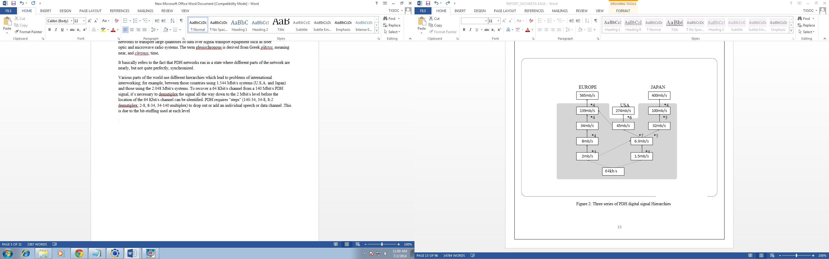

Fig 2.1 Three series of PDH digital signal Hierarchies

1. **Tributary access in PDH**

Since PDH adopts asynchronous multiplexing method, low-rate signals cannot be directly added or dropped from high rate signals. Therefore, adding and dropping must be conducted level by level.

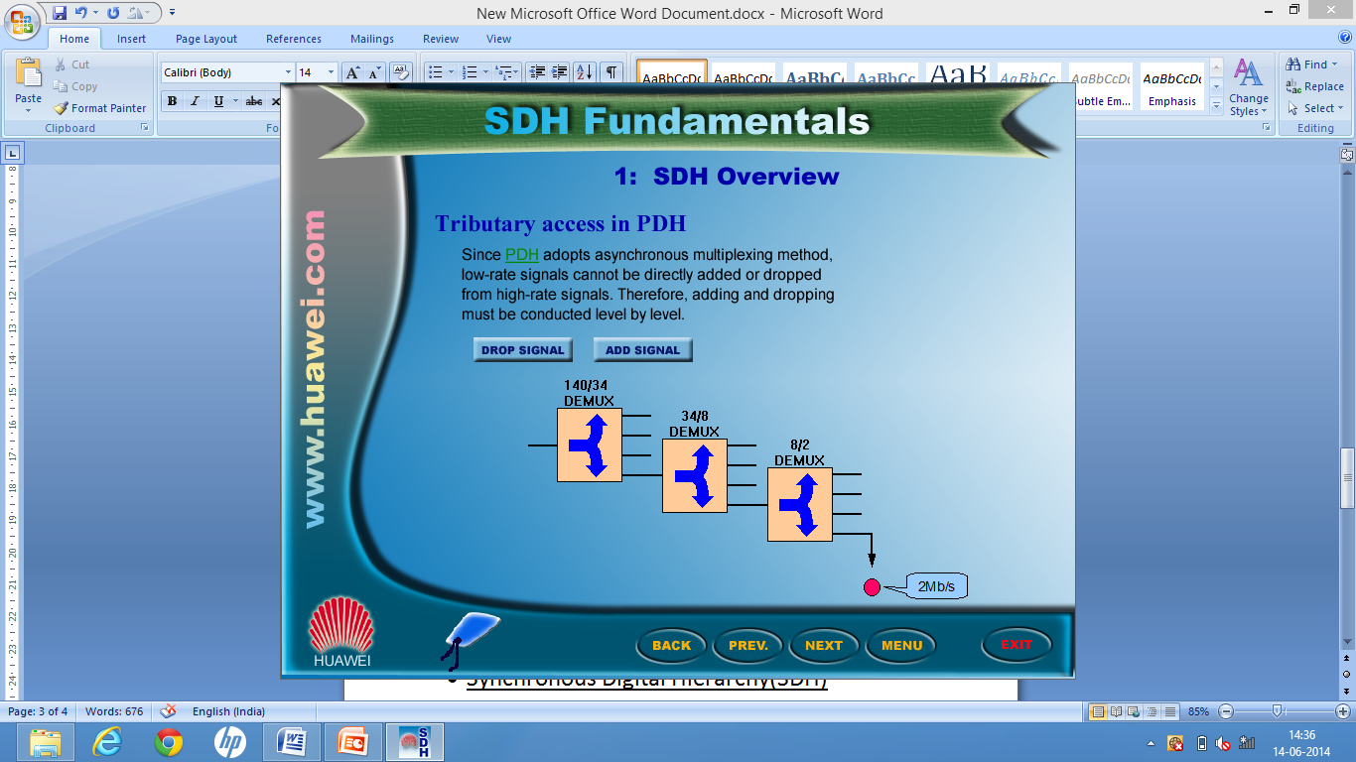

Fig 2.2: Dropping Signal

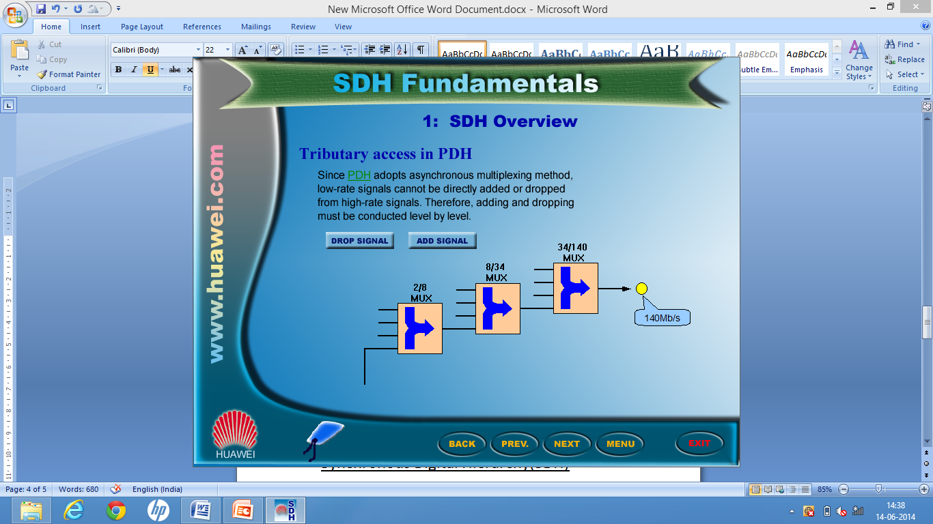

Fig 2.3: Adding Signal

1. **Disadvantages of PDH**
2. Adopts step by step multiplexing and de multiplexing method. This method:

* Increases the cost, power consumption, complexity, and the impairment to the signal.
* Decreases the transmission performance.

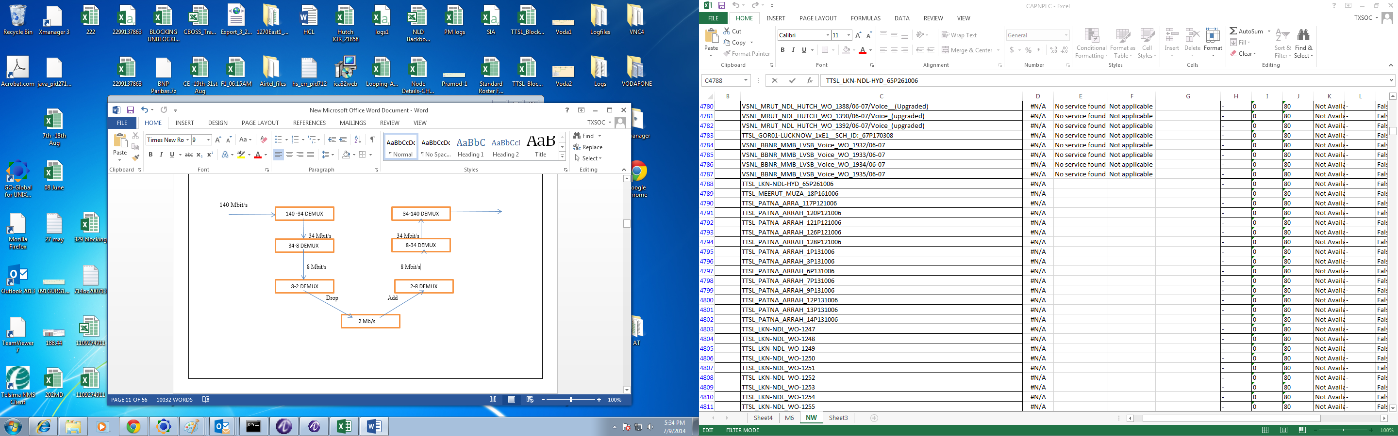

Fig 2.4: PDH multiplexing by steps showing add/drop function.

1. There’s no standardized definition of PDH bit rates greater than 140 Mb/s.
2. There are different hierarchies in use around the world. Specialized interface equipment is required to interwork the two hierarchies.
3. Compatibility of transmission and administration signals between different vendors may give trouble.
4. **SYNCHRONOUS DIGITAL HIERARCHY**

**SDH (Synchronous Digital Hierarchy)** is a standard for telecommunications transport formulated by the International Telecommunication Union (ITU), previously called the International Telegraph and Telephone Consultative Committee (CCITT).

It is a standardized protocol that transfers multiple digital bit streams over optical fibre using lasers or highly coherent light from light-emitting diodes (LEDs). At low transmission rates data can also be transferred via an electrical interface.

1. **Why did SDH emerge?**

* Synchronous transmission has been developed to overcome the problems associated to overcome the problems associated with plesiochronous transmission, in particular the inability of the PDH to extract individual circuits from high capacity systems without having to demutiplex the whole system
* Universal interface (wherever and whenever access network)
* High Speed (Broad bandwidth)

1. **Characteristics of the SDH- bit rate levels**

According to the ITU-T specifications, the bit rates of the lowest level SDH signal (Base Signal) is 155.520 Mb/s which is known as “Synchronous Transport Module” (STM-1)

The line rates of the higher levels are positive integer multiples of STM-1

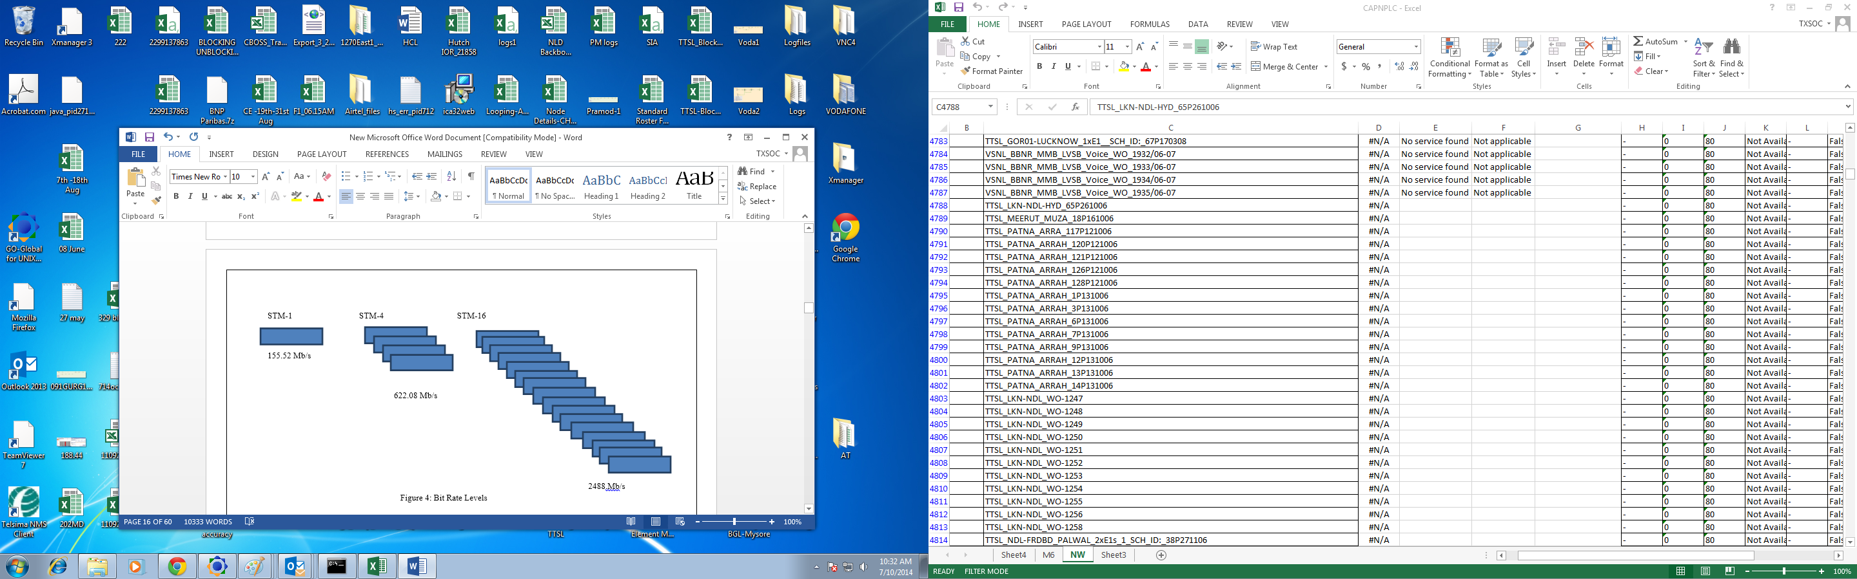

Fig2.5: Bit Rate Levels

1. **Advantages of SDH**
2. Provides universal standards for both electrical and optical interface hence SDH equipment from different vendors can be easily interconnected.
3. Lower rate signals can are multiplexed into higher-rate SDH signals via **BYTE INTERLEAVED METHOD.** Therefore, lower order signals can be directly added or dropped from higher-rate signals.

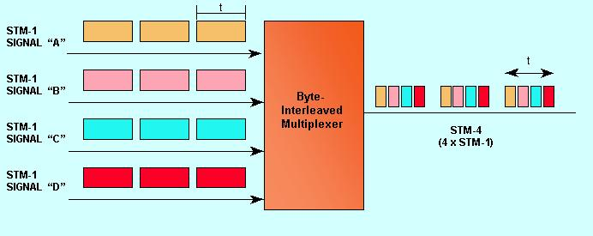

Figure 2.6: Byte interleaved multiplexing method

1. Abundant overhead bits for maintenance operation and administration functions are arranged in the frame structure of SDH signal. Hence the cost of the system is reduced to a great extent.
2. Provides PDH services as well as signals of other hierarchies as well such as, ATM (Asynchronous Transport Module), FDDI (Fibber Distributed Data Interface) and DQDB (Distributed Queue Interface).
3. Provides inter-working between North American and European systems.
4. Extensive network management capability within the hierarchy.
5. **Disadvantages of SDH**
6. Direct adding and dropping of a lower-rate signal is achieved by using pointers. However, the pointers function increases the complexity and causes jitters.

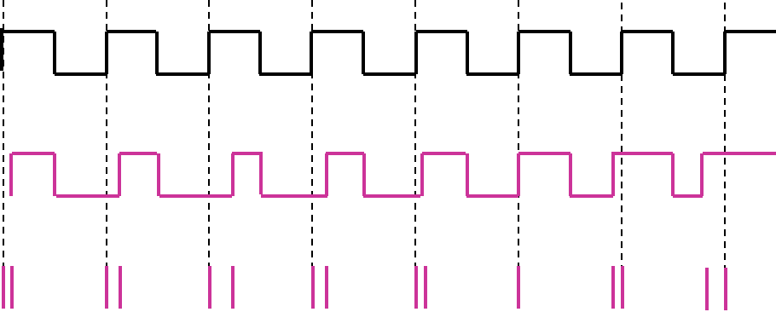

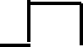 IDEAL SIGNAL

JITTERED SIGNAL

Fig 2.7: Jittering

1. Software plays a large role in the system. As a result, SDH system is vulnerable to computer viruses.
2. Since many overhead bytes are used for operation, administration, maintenance functions, SDH has a lower bandwidth utilization ratio than PDH.
3. **Alarms in SDH network**
4. **Loss of Signal (LOS)**

The first and the major alarm is loss of signal alarm.

1. If there is no physical interface as the fibre/ cable is not connected to the equipment.
2. The power level is less than the threshold level of the receiver sensitivity. (e.g. -24db)
3. If the equipment fails to switch or is hung up.

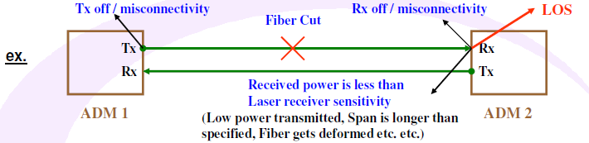

Fig 2.8: Loss of Signal (LOS)

1. **Alarm Indication Signal (AIS)**
2. This alarm is generated due to failure of signal which is prior to our exchange (like MTNL, BSNL etc. which are the local service providers.)
3. When LOS occurred at prior to exchange, this exchange (local service provider) will transmit all, one's to the next or downstream exchanges which indicates that the signal was failed.
4. Even though if the signal is present, and if there was an error in receiving of multiplex section or Regeneration section of SDH, then the exchanges generate MS-AIS or RS-AIS.

**The green line signifies the cable is working fine. The red line signifies there is a failure.**

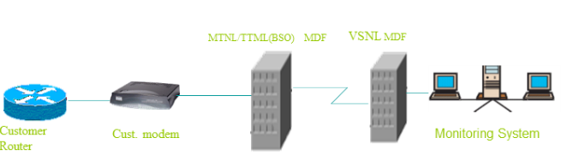

Fig 2.9: No loss generated (smooth transmission)

There is no fibre cut or failure so the transmission takes place smoothly.

Let there be a fibre cut between the customer premises and BSO. Then the LOS is appeared at the BSO exchange and the equipment at BSO receives no signal it injects all one’s into the downstream which indicates AIS for all the downstream exchanges like VSNL.

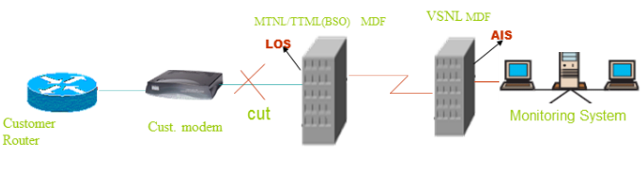

Fig 2.10: LOS and AIS

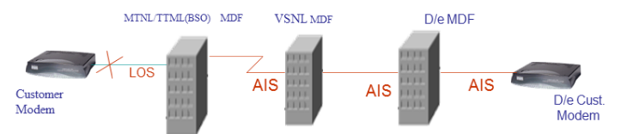

Fig 2.11: LOS and AIS

1. **Remote Defect Indication (RDI)**

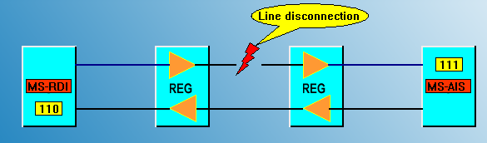

Fig 2.12: Remote Defect Indication (RDI)

If there is a fibre cut/ line disconnection then the receiver interprets the message of alarm indication signal. Meanwhile the opposite side interprets a message of RDI (Remote Defect Indication).

As discussed in section part about K2 byte. The 6, 7, 8 bits of K2 byte are used to realize this error.

If these bits are set to ‘111’ and then transmitted, the receiver interprets the message of AIS.

And it sets a bit pattern of ‘110’ which is sent to the opposite direction.

**NOTE: LOS, AIS and RDI are port level alarms and can hence be detected in the equipment.**

1. **Troubleshooting Port Level Alarms**
2. **Segment wise testing**

This is primary test used to find the exact location of the problem in the transmission path.

1. **Steps for testing**

Step1: Ask the customer whether the customer modem is switched off or not. If the modem is off it will inject LOS to nearest BSO and the BSO will inject AIS to entire downstream.

Step2: if the customer modem is working fine take the loop from customer modem and check on the meter whether the same loop is being received or not or else we can ask customer to check loop by providing loop towards the customer. Hence, the traffic at both ends is checked.

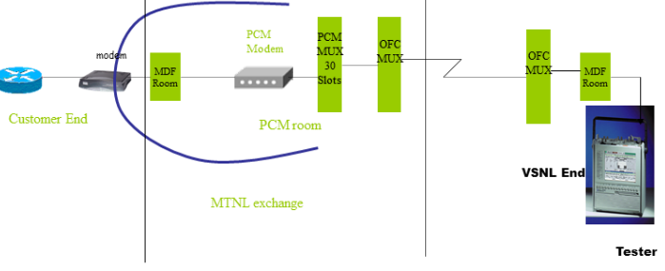

Fig 2.13: Testing Link

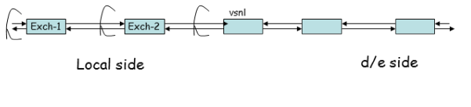 Fig 2.14: Testing Link

If the customer is not getting the loop means that there is a fibre cut somewhere in between. Hence, if we are getting AIS from distend end to end loop the same loop test is being carried **out.**

1. **Out of Frame (OOF) and Loss of Frame (LOF)**

Out of frame is a minor alarm generated and happens in a rare condition. It is a circuit level alarm that is we cannot detect it in the port and a tester is being used to detect it.

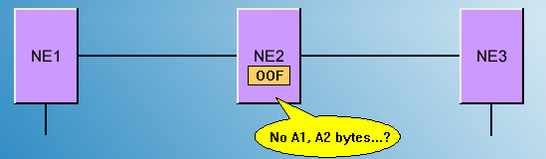

Fig 2.15: Out of Frame (OOF)

If there is a service between NE1 and NE3.

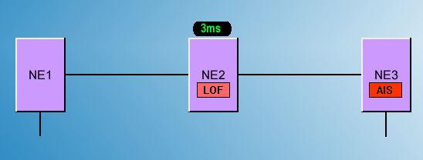If NE2 doesn’t receive any A1, A2 bytes within five or more successive frames, it generates out-of frame alarm.

Fig 2.16: Loss of Frame (LOF)

If the OOF keeps for 3ms, NE2 generates the loss-of frame alarm. Meanwhile an AIS signal will be sent downwards and the service will be interrupted.

1. **Causes of SDH alarms**
2. **Fibber faults**

* There are several reasons of fibre fault like fibre cut due to road expansion work, Pipeline work, Construction work.
* Sometimes the fibre degrades or the signal degrades inside the fibre this is known as the fibre loss (attenuation.). It generally happens when the signal isn’t getting enough power to reach the receiving end.

**Ensure that the cable is hooked up to the correct ports. Correct the cable connections if necessary.**

**A segment wise testing is done to make sure that which segment is actually generating losses as discussed above.**

1. **Equipment level fault**

* The alarms can also be generated when the equipment is faulty. Sometimes in some situations equipment failure takes place.
* Or else equipment is hung up due to some technical problems.
* Elements of the equipment like the fan or the port can also be faulty due to which an alarm is generated.

**As the problem is detected the part is being replaced or corrected.**

1. **Natural calamities**

* Sometimes, a fibre cut happens due to the extreme weather conditions. For e.g. mud slides, ice storms etc.
* Earthquakes or floods and other natural disasters causes a fibre cut and normally all fibres in a cable get affected**.**

1. **Event classification**

SOC will be accountable to determine the Event Classification for the Network related event and update the CHD through the ticketing system. Event can be classified in three types:

1. **AR – At Risk:** An unplanned situation that represents a threat for the continuity of service over a large Customer base or multiple selected Platinum accounts.
2. **ME – Major Event**: A service-impacting event affecting a large Customer base or multiple Platinum accounts. It is of three types:

* ME1: Outage impacting 25 to 35 customers.
* ME2: Outage impacting 15 to 25 customers.
* ME3: Outage impacting less than 15 customers.

1. **CE – Crisis Event**: An event impacting more than 35 customers and for which no resolution is expected before at least 72hrs.
2. **SDH NETWORKING**
3. **INTRODUCTION**

An SDH network consist of Network Elements (NE) interconnected with optical fibre. The geometrical layout of NEs and transmission lines is called the network topology.

The efficiency, reliability and cost-effectiveness of the network highly depends on its topology.

1. **CLASSIFICATION OF TOPOLOGY STRUCTURES**
2. **Chain network**

In chain networks, all the nodes are connected one after another on a line with both ends open.

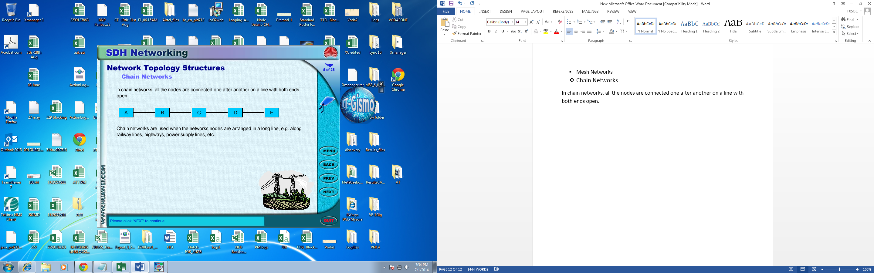

Fig 3.1: Chain network

Chain network are used when the network nodes are arranged in a long line, e.g. along railway lines, highways, power supply lines, etc.

* **Advantages**
* Economical to build.
* Easy to operate, administrate and maintain.

1. **Star Networks**

In star networks, there is a central node to which all the other nodes are directly connected. There are no direct links between other nodes.

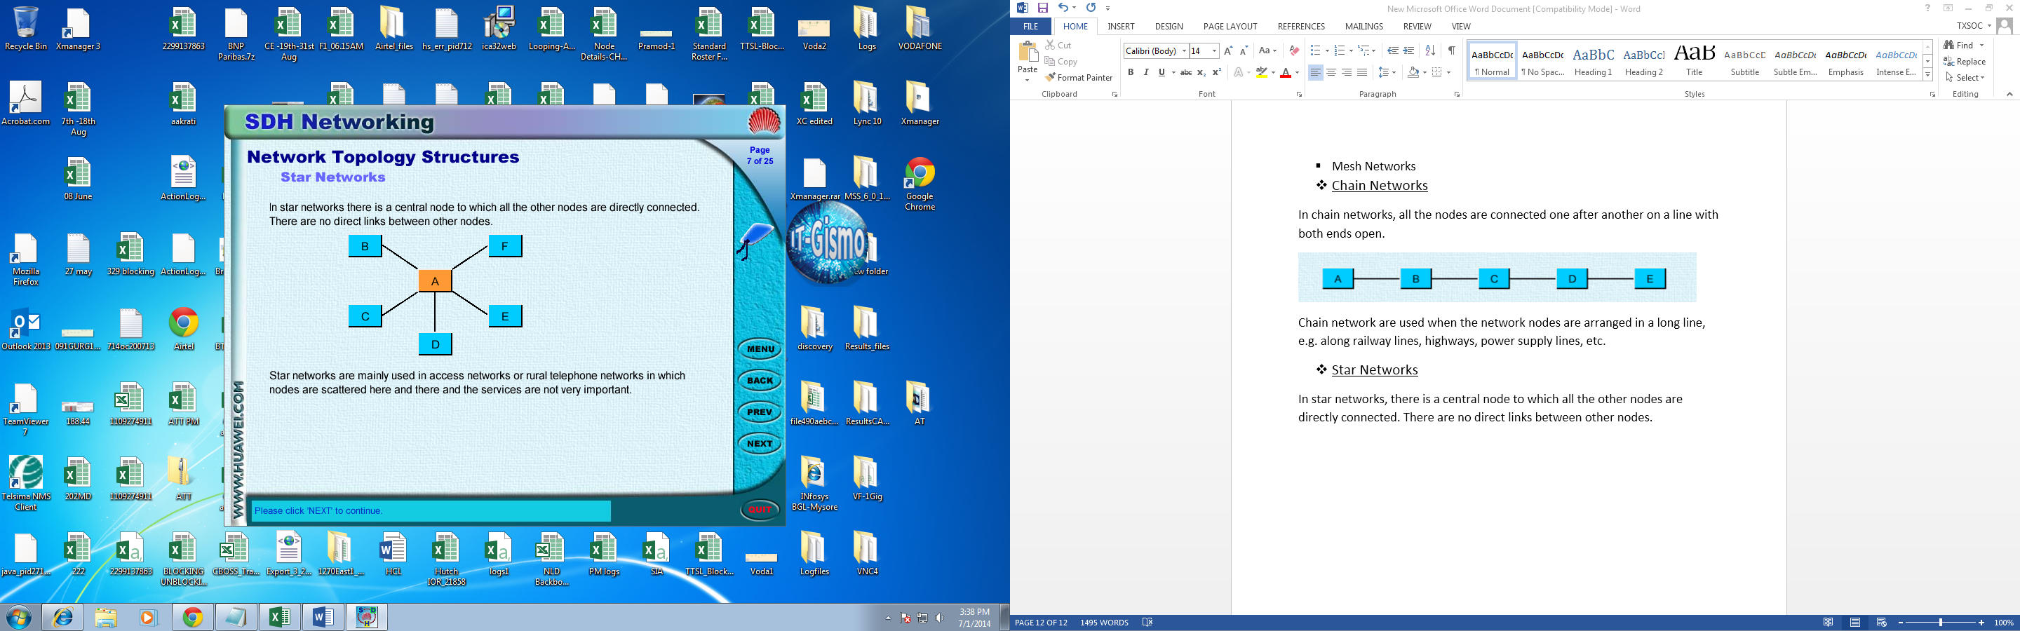

Fig 3.2: Star network

Star networks are mainly used in access networks or rural telephone networks in which nodes are scattered here and there and the services are not very important.

* **Advantages**
* Have the capability of managing the bandwidth comprehensively and flexibly.
* **Disadvantages**
* There is a potential bottleneck of the bandwidth at the central node.
* An equipment failure of the central node may cause a breakdown of the entire network.

1. **Tree Network**

A tree network can be considered as a combination of the chain and the star topologies.

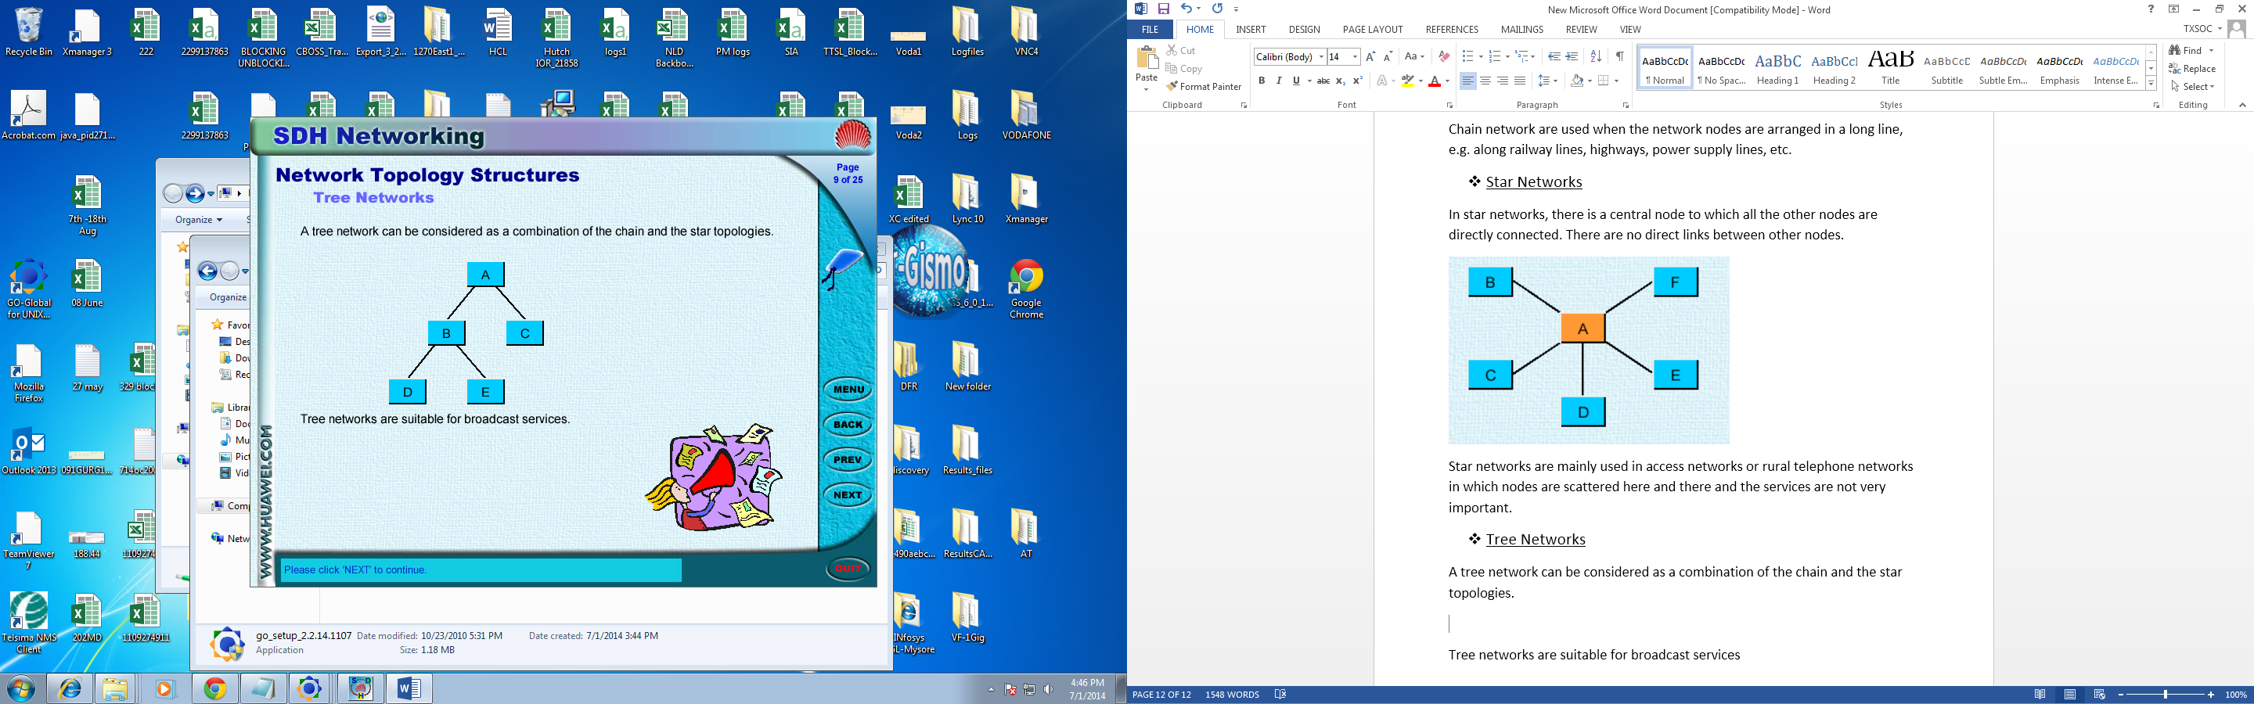

Fig 3.3: Tree network

Tree networks are suitable for broadcast services.

* **Advantages**
* Have the capability of managing the bandwidth comprehensively and flexibly.
* Economical to build.
* Easy to operate, administrate and maintain.
* **Disadvantages**
* Not suitable for bi-directional services.

1. **Ring Network**

Ring networks are such structures in which all the nodes are connected one after another to form a circle.

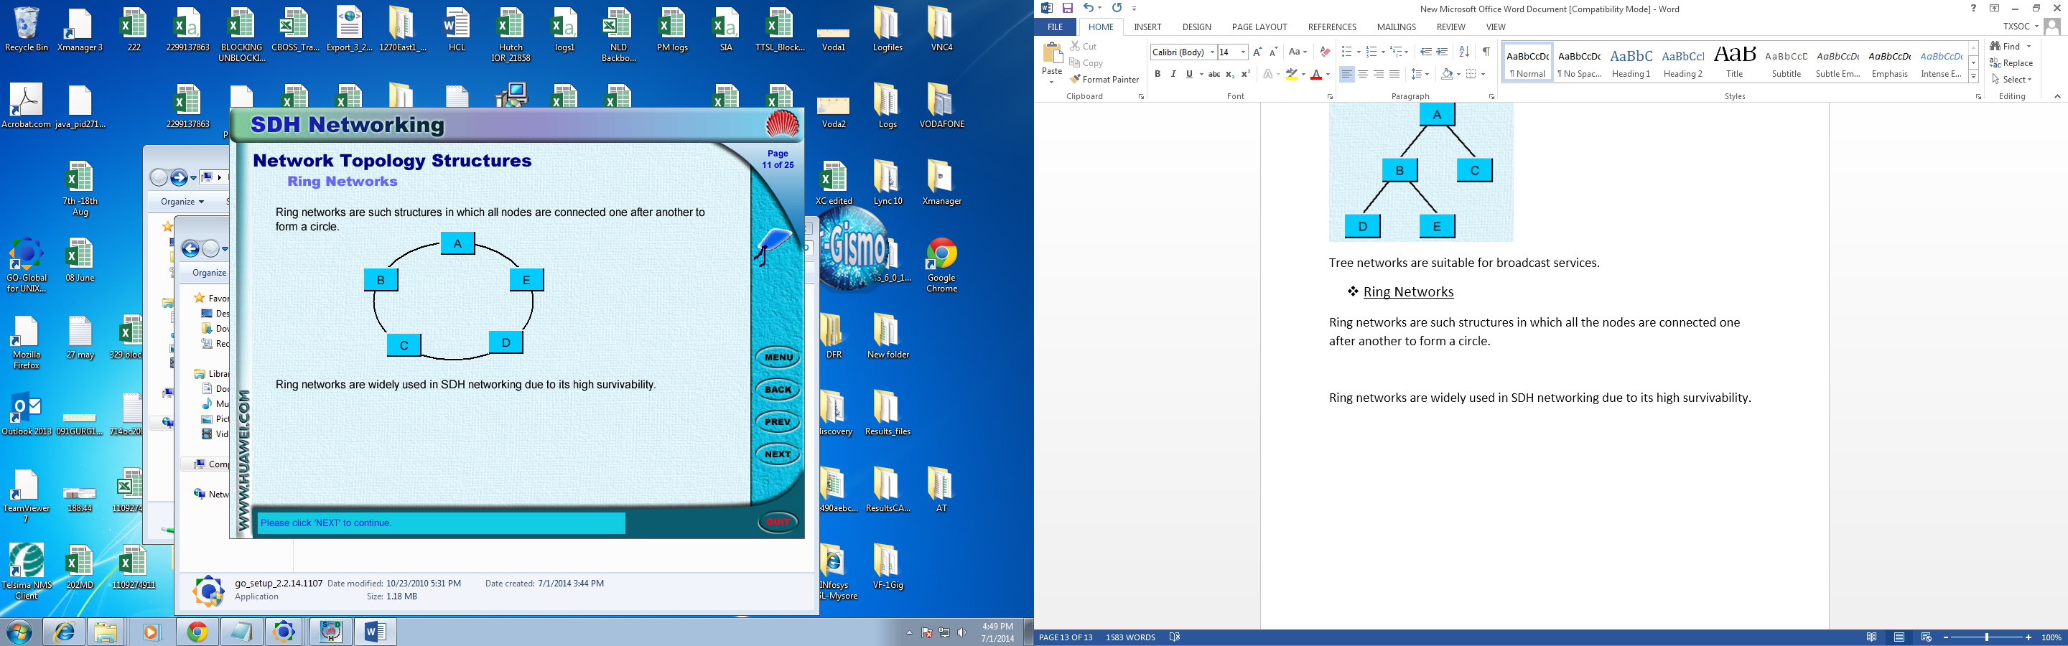

Fig 3.4: Ring network

Ring networks are widely used in SDH networking due to its high survivability.

* **Advantages**
* High survivability.
* High reliability.
* **Disadvantages**
* Difficult to maintain.
* The network nodes must be configured very complex.

1. **Mesh Network**

Mesh networks are such structures in which many nodes are interconnected via direct links.

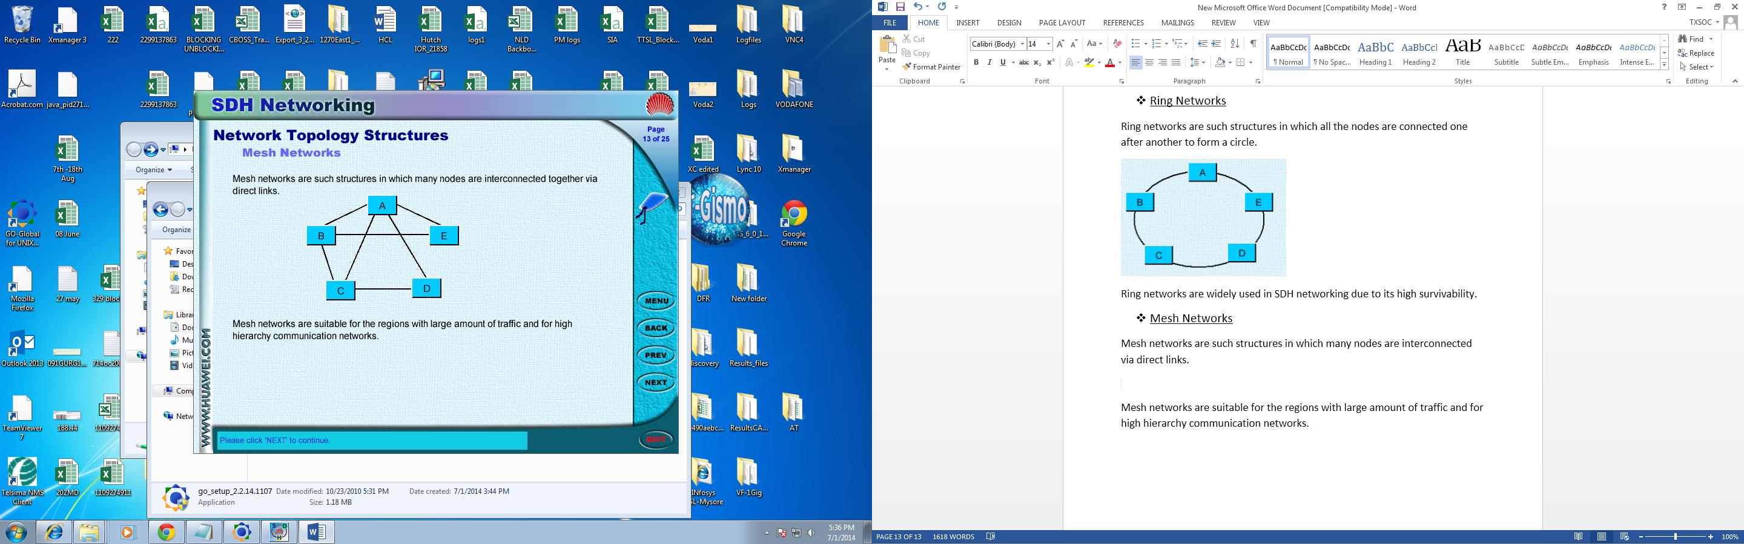

Fig 3.5: Mesh Network

Mesh networks are suitable for the regions with large amount of traffic and for high hierarchy communication networks.

* **Advantages**
* No traffic bottleneck problems exists
* Highly reliable
* **Disadvantages**
* Complicated
* Costly
* Difficult to maintain

**IV. AUTOMATION PROJECT (‘SPOTLIGHT’)**

Spotlight is a real-time fault management system for network issues that helps in successful network management and support efficient Root Cause Analysis (RCA) of network related issues. This in return then helps in successful correlation &

Alerts in Fault Management System (FMS) resulting in proactive ticketing for TX services. This improves the resolution efficiency resulting in improvement in Customer Satisfaction (CSAT).

In spotlight, ‘Cignet’ will be used to monitor the live network and detect the location of the alarms in the circuit along with its type. Further, ‘Cramer’ is used to get the desired information which is a database comprising of the details of all the circuits. Spotlight will co-relate both the tools (Cignet and Cramer) to get the desired Root Cause Analysis (RCA), we finally get the desired information regarding any type of alarms without the need of manual intervention i.e. troubleshooting each and every port in the circuit. The ‘Spotlight’ records all the information and finally, the Field Engineer (FE) is contacted and is told to resolve the fault.”

**Virtual network:**

The network which is used by Tata communications limited (**TCL**) to provide network services but which is not owned or laid down by them is known as virtual network (third party network used for providing network services to customers).

NODE

C

NODE B

NODE A

BHARTI’S NETWORK

TCL’S NETWORK

Fig 4.1: virtual network

TCL is providing a network service from node A to node C even though the network from node B to node C is not owned by them, hence the network from node B to node C is treated as virtual network.

**A GROUP OF NETWORK ELEMENTS IS CALLED A EMS AND A GROUP OF EMS IS CALLED NMS**

**EMS: ELEMENT MANAGEMENT SYSTEM**

**NMS: NETWORK MANAGAMENT SYSTEM**

SPOTLIGHT fetches alarms from the EMS at the KLM level through its mediation layer ( the interface between the physical equipment and the software) but as the virtual network alarms are masked at the KLM level SPOTLIGHT is unable the fetch the alarms on the virtual network

**Enabling alarms on virtual network**

NODE B

NODE C

2

1

ALARM ON SEGEMENT 1-2

Fig 4.2: alarm on virtual network

* If there is a fibre cut at the segment 1-2 then a LOS(loss of signal) alarm will be generated but spotlight won’t fetch this alarm
* The customer availing service from node A to node C will complain about the link being down but spotlight won’t show any alarms as the fibre cut is on the virtual network.

Enabling an alarm means that it should be detected on the nearest Network element of TATA’S network. In this case an alarm should be generated on node B as it is the nearest network element of Tata’s network that connects to the virtual network.

**Project to enable invisible alarms**

* My project was to enable such alarms at the KLM level on the ECI equipment.
* Crammer is the DATABASE of the Tata’s network it has the routing details to each and every network element.
* The crammer IT team was told to provide us with details of the network element that connects to the virtual networks.

**Procedure to enable alarms**

1. Login on ECI-EMS
2. Open the EMS( Chennai in this case)
3. Open the network element( CHNI_XDM2K_63_ARCH in Chennai EMS)

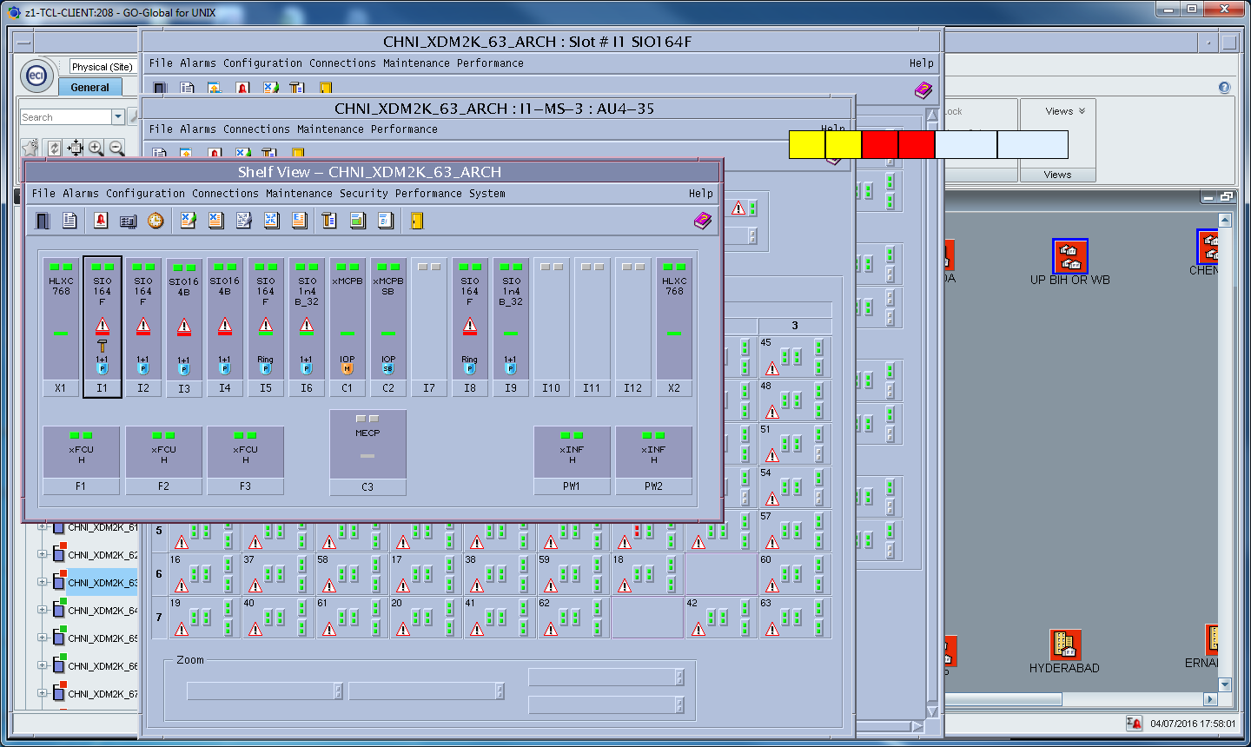

Fig 4.3: network element on eci

1. Open the port

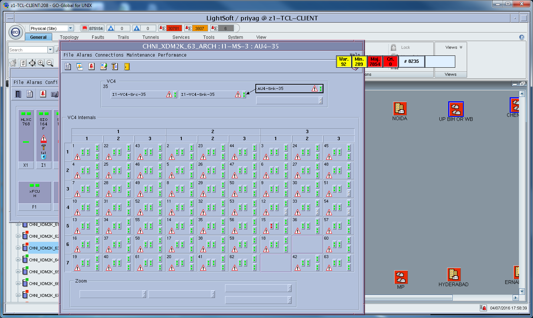

Fig 4.4: port of the NE

1. Open the alarm severity assignment of the KLM

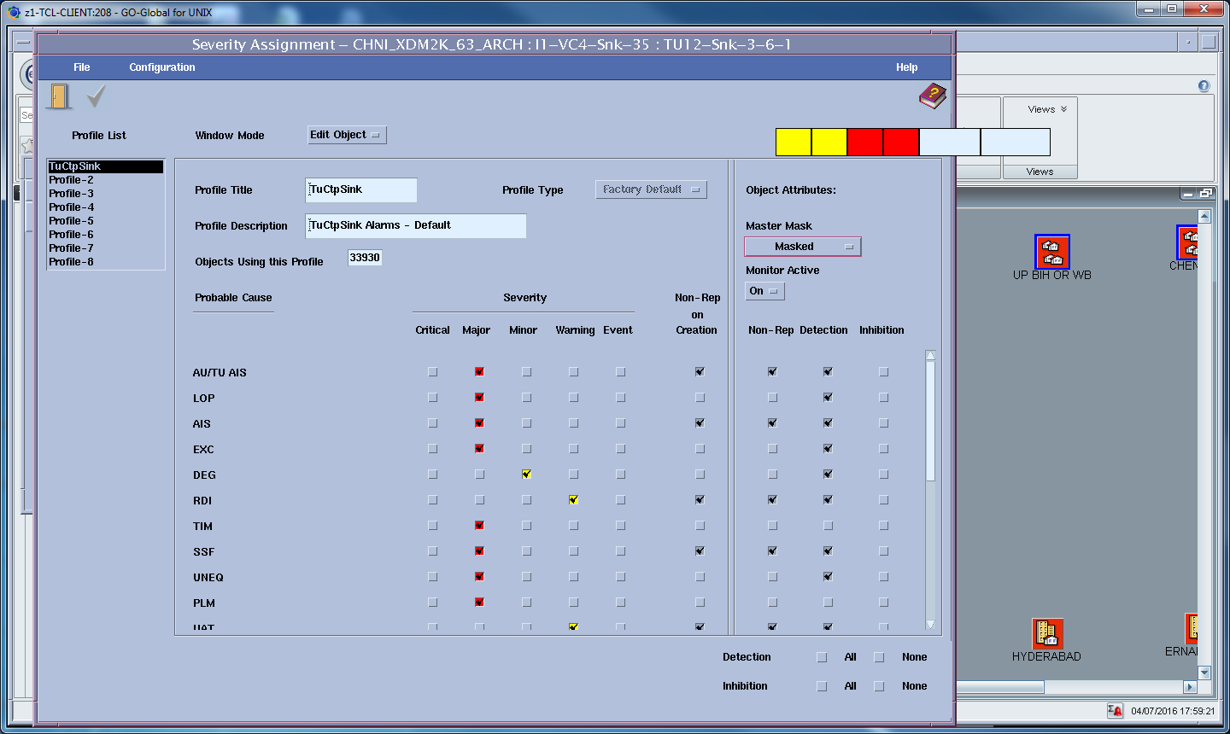

Fig 4.5: alarm severity assignment

1. Set the master master mask to monitored

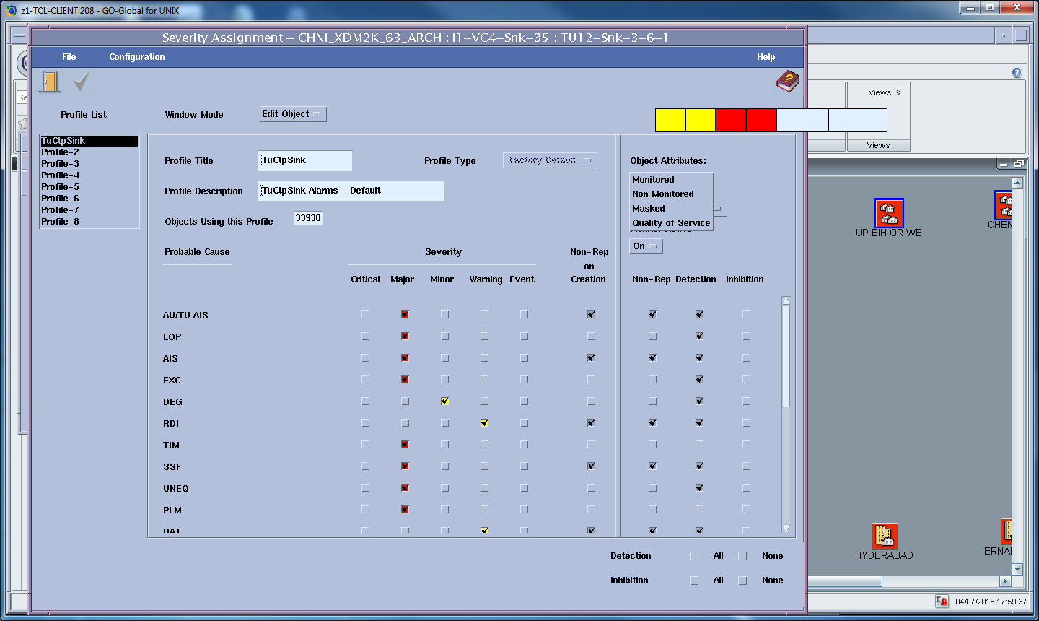

Fig 4.6: master mask

1. Uncheck all the flags on the non-rep.

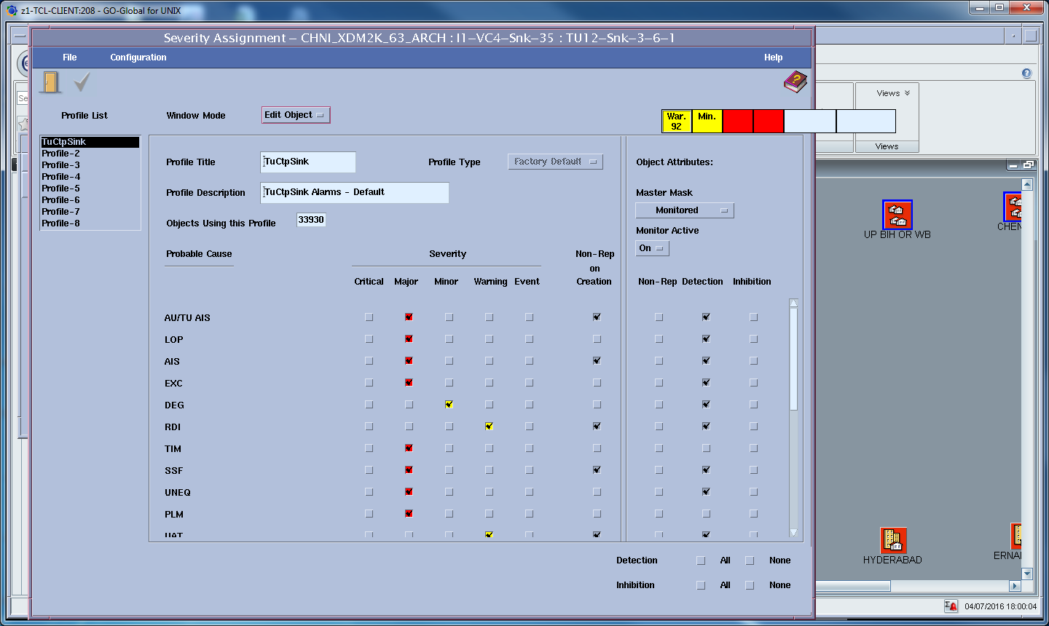

Fig 4.7: enabled alarm

**AFTER THIS PROCEDURE THE ALARM IS ENABLED ON THE KLM LEVEL.**

**V. BIBLOGRAPHY**

* SDH Telecommunications Standard Primer by Tektronix ([www.tektronix.com](http://www.tektronix.com))
* Wikipedia (www.**wikipedia**.org/‎)
* Slideshare (www.**slideshare**.net/‎)
* Google (<https://www.google.co.in/>)